Church of St. Ignatius of Loyola Solemnity of the Most Holy Trinity

Processional Hymn Holy, Holy, Holy! Lord, God Almighty 553
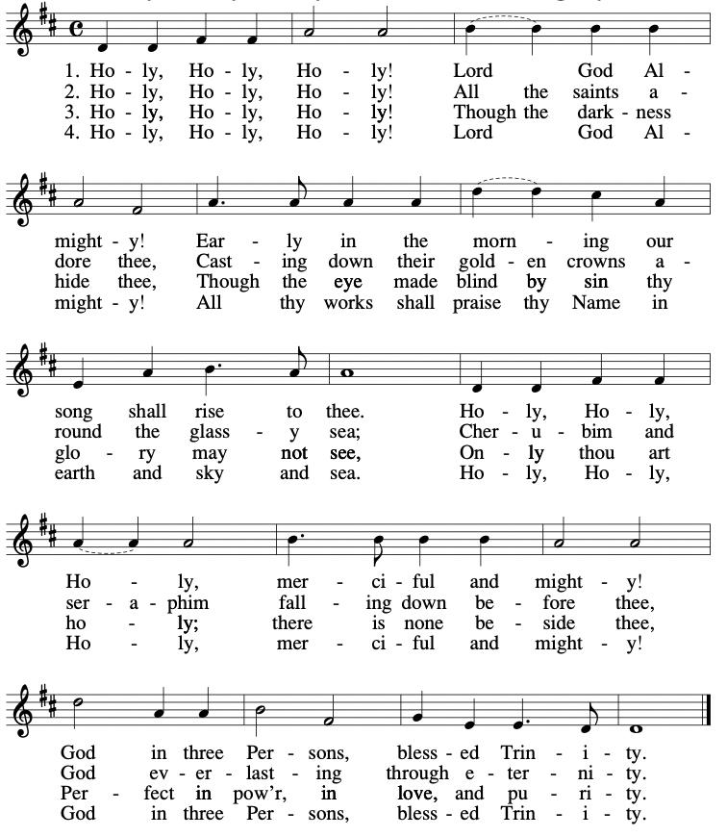

Gloria Sat. 4pm, Sun 10:30am [5pm in seasonal response sheet] Congregational Mass 324

Responsorial Psalm Daniel 3
“Glory and praise forever!”
Gospel Acclamation [found in seasonal response sheet]

Preparation of the Gifts Come, Join the Dance of the Trinity 554
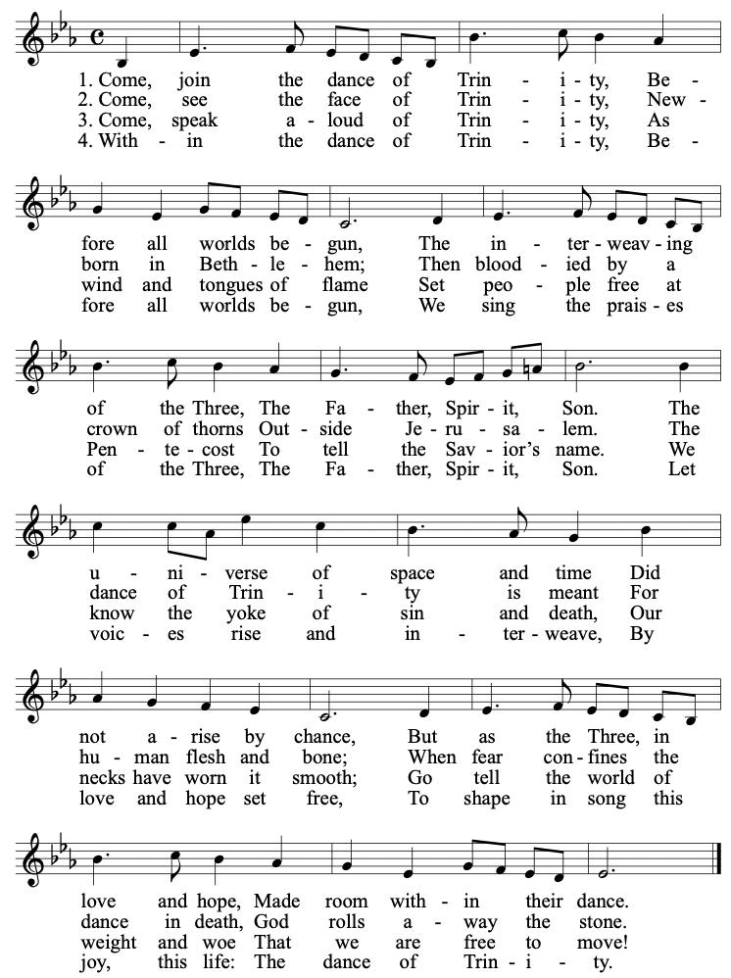

Eucharistic Acclamations [found in seasonal response sheet]

Communion Hymn I’ll Walk By Your Side JoJo David
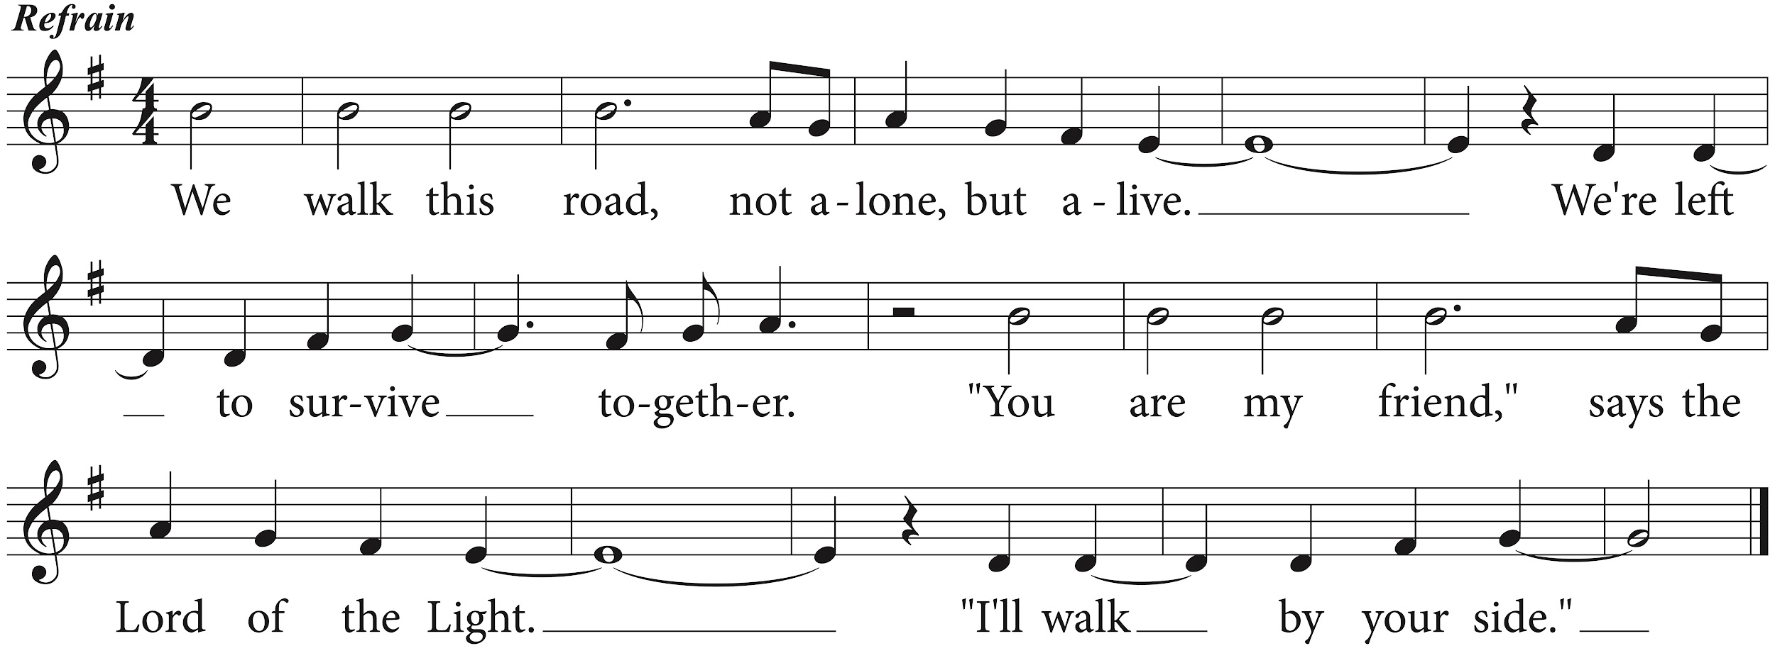

Recessional Hymn O God, Almighty Father 551
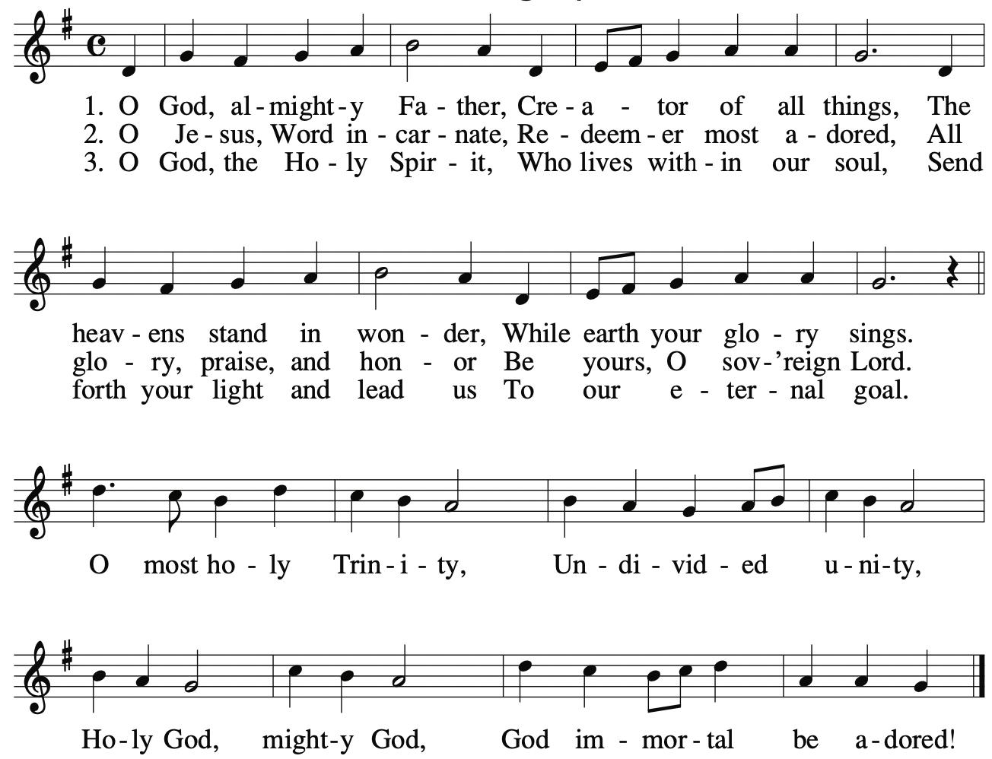

Please return the worship programs to the tables.

Excerpts from the English translation of the Roman Missal © 2010 International Commission on English in the Liturgy Corporation.
Reprinted with permission under ONE LICENSE A-730270. All rights reserved.
Please return unwanted programs to the tables at the exits and scan QR to donate:

